24/08/2026 – Text to Image

AI Tool – OpenArt AI
Prompt:
A luxurious dark fairytale book poster inspired by Once Upon a Broken Heart. An enchanted fantasy kingdom at twilight, filled with towering candy-colored castles, ornate golden architecture, magical forests and winding paths covered in crimson roses and glowing flowers. In the center stands a beautiful young woman in an elegant flowing rose-colored fairytale gown, holding a single glowing golden apple close to her chest. Behind her stands a mysterious, handsome immortal Fate dressed in an elaborate black and crimson royal coat, watching her with an enigmatic expression.
Between them floats a magical golden heart, cracked down the center, surrounded by sparkling magical dust and delicate rose petals. A grand enchanted castle rises in the background beneath a huge luminous moon, while twisted thorn-covered trees frame the scene. Tiny glowing butterflies drift through the air. The atmosphere is romantic, whimsical, mysterious and slightly sinister, like a beautiful fairytale hiding a dangerous curse.
Rich crimson, dusty pink, deep midnight blue and antique gold color palette, luxurious baroque details, intricate costumes, magical realism, dreamy cinematic lighting, dramatic moonlight, soft mist, glowing particles, highly detailed fantasy illustration, elegant composition, sophisticated dark fairytale aesthetic, vertical book-poster composition, breathtaking and enchanting.
Leave elegant empty space at the top for the title “ONCE UPON A BROKEN HEART” and smaller space underneath for “STEPHANIE GARBER”. Ornate decorative typography, perfectly legible text, no watermark, no additional text.

Image generated:
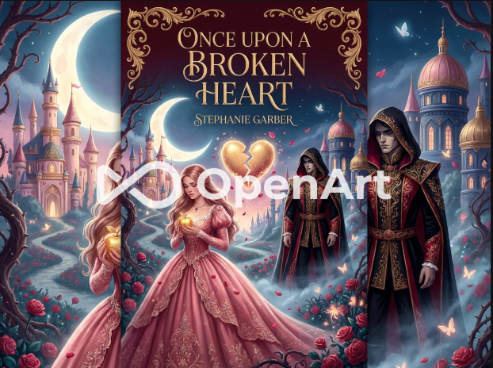

AI Tool – Ideogram AI
Prompt:
A terrifying cinematic zombie apocalypse movie poster showing the last surviving human city at night, surrounded by an enormous horde of thousands of zombies. The city is barely surviving behind huge metal barricades and fortified walls, with soldiers desperately defending the gates. Outside the walls, an endless sea of infected humans floods the streets, climbing over abandoned cars, wreckage, and each other to reach the city. In the foreground, a small group of exhausted survivors stands on top of a damaged military vehicle, armed and preparing for their final stand. Their clothing is torn and covered in dirt and blood, their faces showing fear, exhaustion, and determination. Behind them, thousands of terrifying zombies emerge from thick smoke and fog, with pale decaying skin, torn clothing, glowing reflections in their eyes, and horrifying expressions. The skyline is filled with burning buildings, black smoke, helicopters, collapsing structures, sparks, and explosions. A massive blood-red moon hangs behind the ruined city, illuminating the zombie horde. Rain falls heavily through the scene, reflecting neon lights and fire across the wet streets. Epic Hollywood zombie thriller movie poster, dark atmospheric horror, photorealistic, ultra-detailed, dramatic lighting, volumetric fog, cinematic depth, realistic destruction, intense scale, high contrast, terrifying but visually beautiful, gritty textures, dark blue and crimson color palette, 4K, IMAX cinematic composition. Leave clean negative space at the top for the movie title and at the bottom for movie credits. No text, no watermark, no logos.

Image generated:
